

A Project Report On

**Library Management System**

**By**

**Mubasshirin Tamboli**

**B.E**

**Batch:** 2021 – 6024

**Center: Pune**

Under the Guidance of,

**Nisha Jaiswal**

**Technical Trainer**

**EduBridge**

(School of coding)

**Introduction:**

The project “Library Management System” explains about the e-library website. The project “Library Management System” deals with various tasks related to library. This project provides the facility to register the librarian or student, add books, view books, issue book, return book and view issued books. Our Project Include

**Modules:-**

* Admin Module
* Librarian Module
* Student Module

I have developed this Application in **Java, JSP, Spring Boot, JPA and MySQL.** It’s a web-based projects so I have used **HTML, CSS, JavaScript and Bootstrap also**.

The main feature of the project is to make the tasks related to library easy. You can access this website from anywhere and everywhere.

In Admin module, admin can add/register the librarian and student in the specific category. He can also view all the librarian and students available. He can edit or delete any librarian or student if needed.

In Librarian module, librarian can add books available in the library. He can view all the books available in the library .He can delete any book if needed. He can issue book, return book and view issued books.

In Student module, student can view books, view profile and view books issued by him or her.

**Software Requirements:**

**Front end:** Java, JSP, Spring Boot, JPA, HTML, CSS, JavaScript, Bootstrap

**Back end**: MySQL workbench 8.0.23CE.

**Middleware/Server:** Spring Tool Suite

**Browser:** Best result on Google Chrome

**Operating System:** Window 7.

# UML Diagrams:-

# Use Case Diagram

# 

Figure: Use case Diagram for Library Management System

* **Sequemce Diagram:**

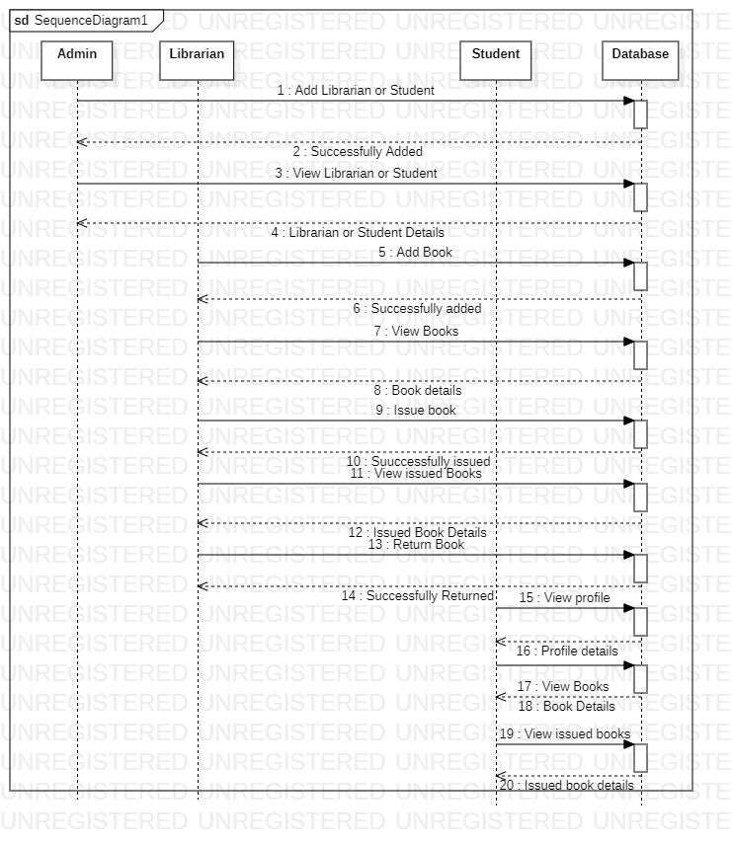

Figure: Sequence Diagram for Library Management System

* **Class Diagram**

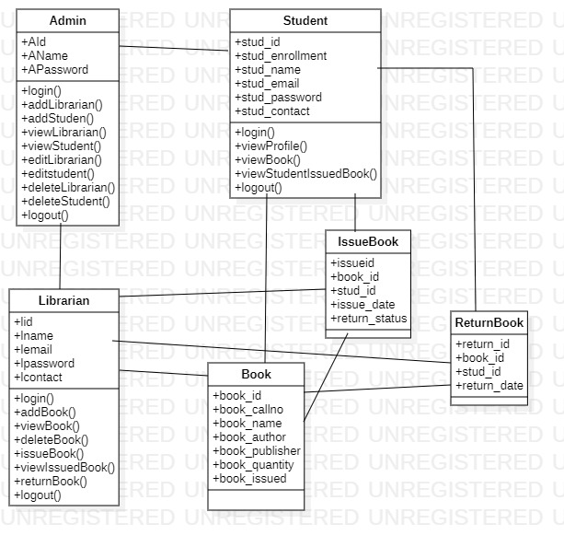

Figure: Class Diagram for Library Management System

# Database Structure:

Database Name: LibraryManagement

Table: Admin

Table structure:

|  |  |  |
| --- | --- | --- |
| Field | Datatype | Constraint |
| aId | int | Primary Key Auto_increment |
| aName | varchar(20) | Not Null |
| aPassword | varchar(20) | Not Null |

Table: Librarian

Table structure:

|  |  |  |
| --- | --- | --- |
| Field | Datatype | Constraint |
| Lid | int | Primary Key Auto_increment |
| lname | varchar(20) |  |
| lemail | varchar(20) | Not Null |
| lpassword | varchar(15) | Not Null |
| lcontact | Varchar(15) |  |

Table: Student

Table structure:

|  |  |  |
| --- | --- | --- |
| Field | Datatype | Constraint |
| stud_id | int | Primary Key Auto_increment |
| stud_enrollment | Varchar(20) | Unique Key |
| stud_name | varchar(20) |  |
| stud_email | varchar(20) | Not Null |
| Stud_password | varchar(15) | Not Null |
| Stud_contact | Varchar(15) |  |

Table: Book

Table structure:

|  |  |  |
| --- | --- | --- |
| Field | Datatype | Constraint |
| book_id | int | Primary Key Auto_increment |
| book_name | varchar(25) |  |
| book_author | varchar(20) |  |
| book_publisher | varchar(20) |  |
| book_quantity | int |  |
| book_issued | int |  |

Table: IssueBook

Table structure:

|  |  |  |
| --- | --- | --- |
| Field | Datatype | Constraint |
| issueid | int | Primary Key Auto_increment |
| book_id | int |  |
| stud_id | int |  |
| issue_date | date |  |
| return_status | varchar(10) |  |

Table: ReturnBook

Table structure:

|  |  |  |
| --- | --- | --- |
| Field | Datatype | Constraint |
| return_id | int | Primary Key Auto_increment |
| book_id | int |  |
| stud_id | int |  |
| return_date | date |  |

# Screenshots:-

**Home Page:**

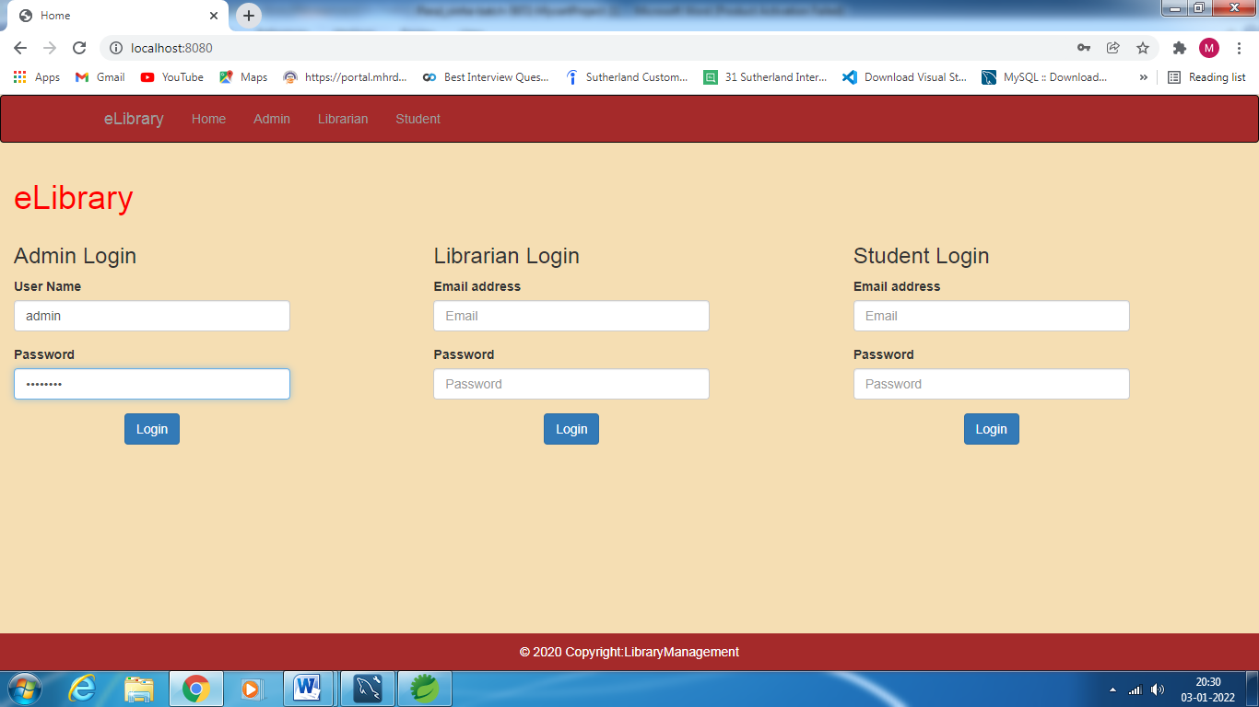

**Admin Home Page:**

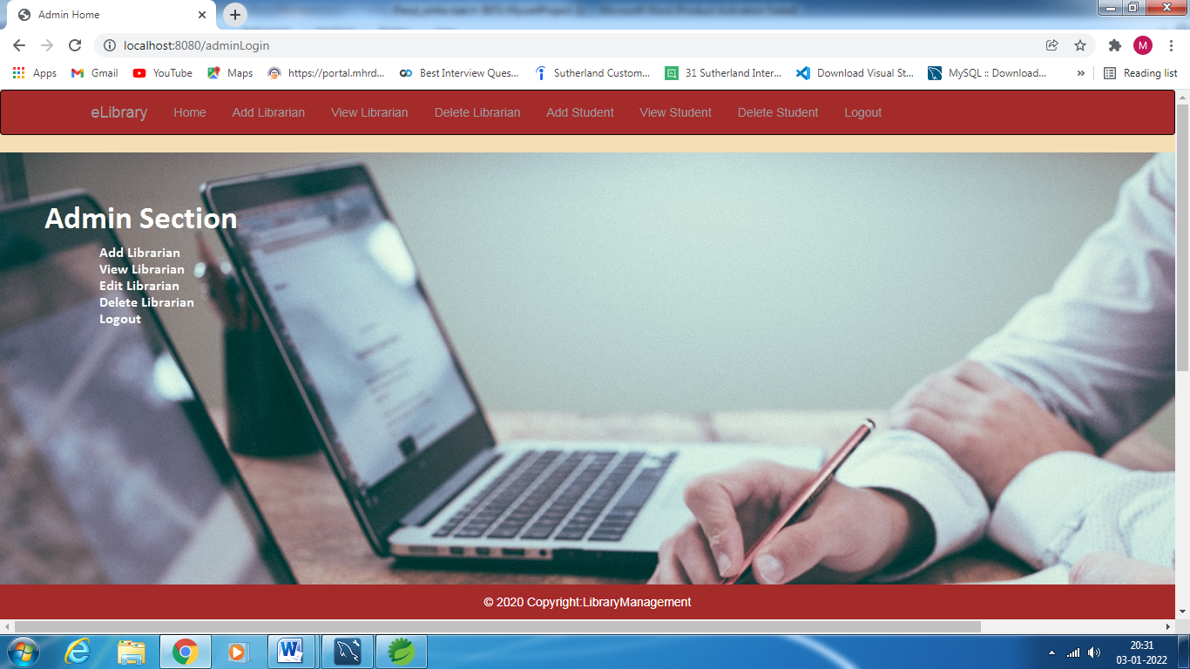

**Add Librarian Page:**

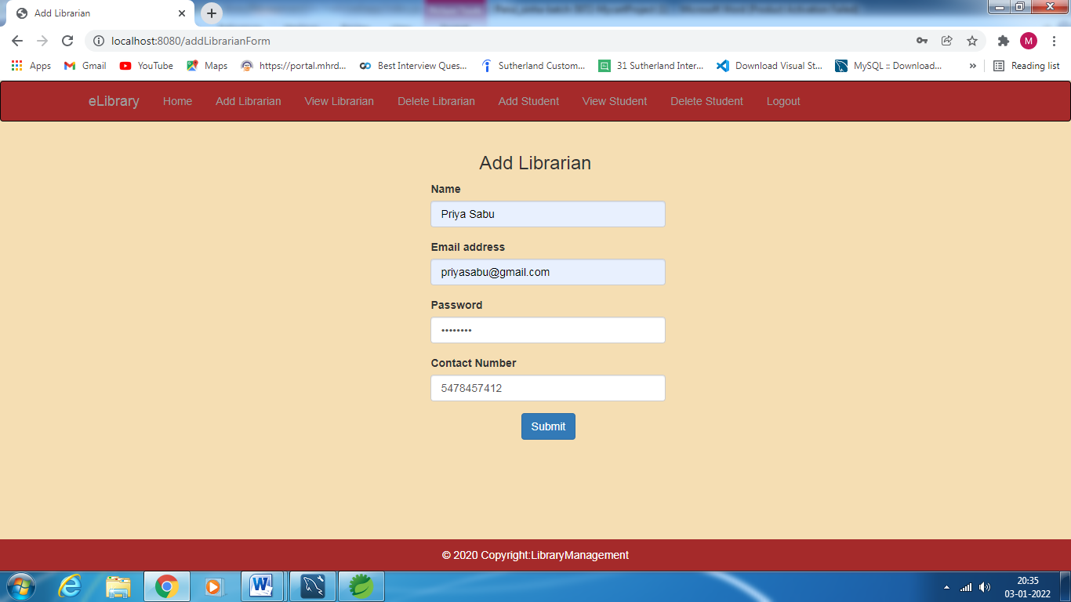

**View Librarian Page:**

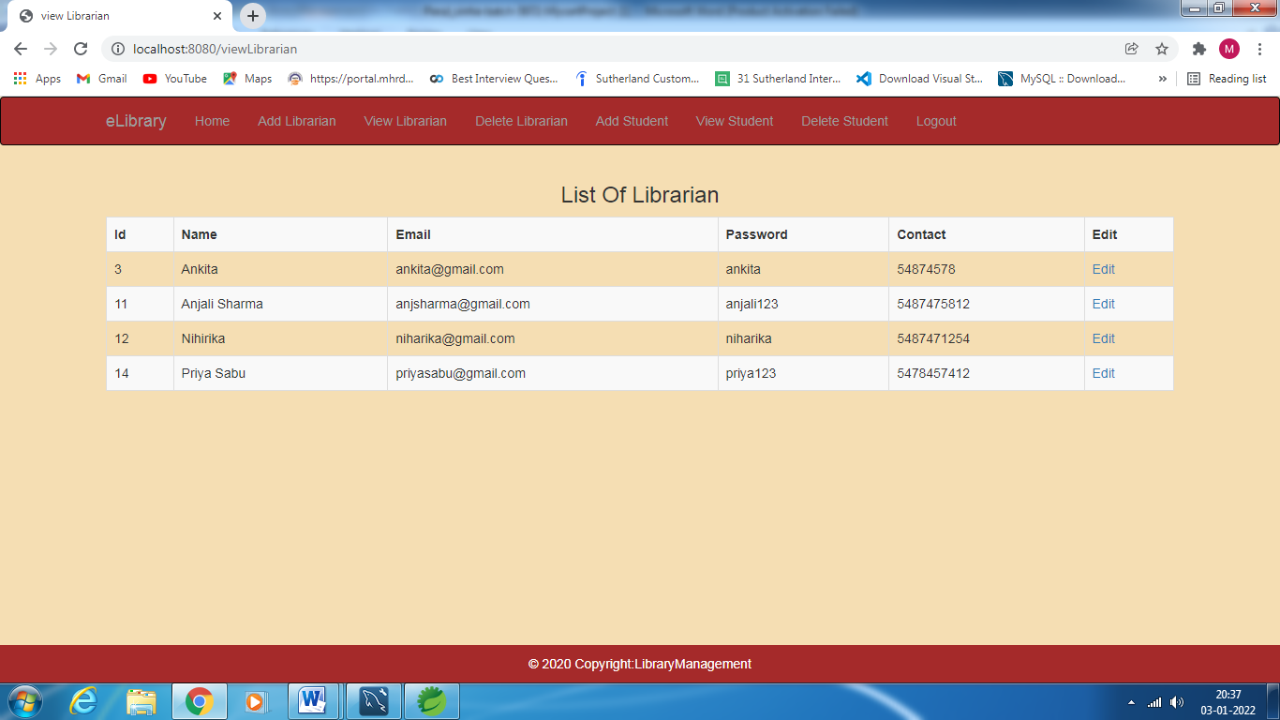

**Edit Librarian Page:**

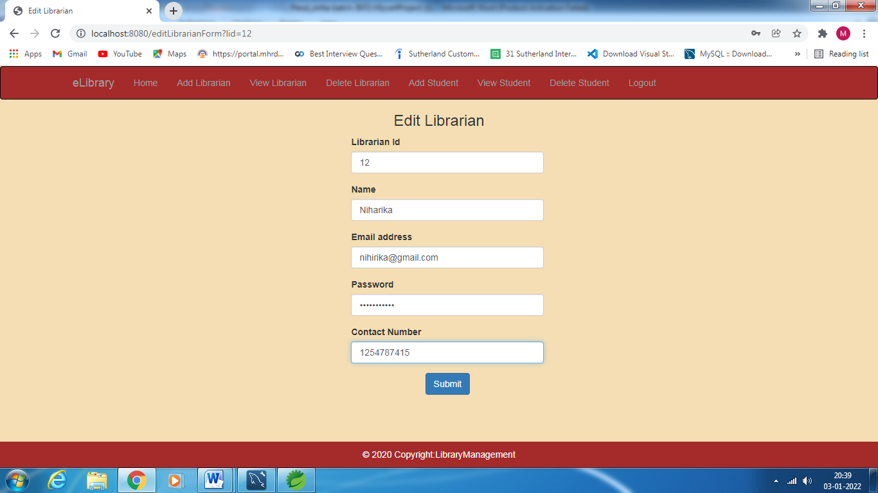

**Delete Librarian Page:**

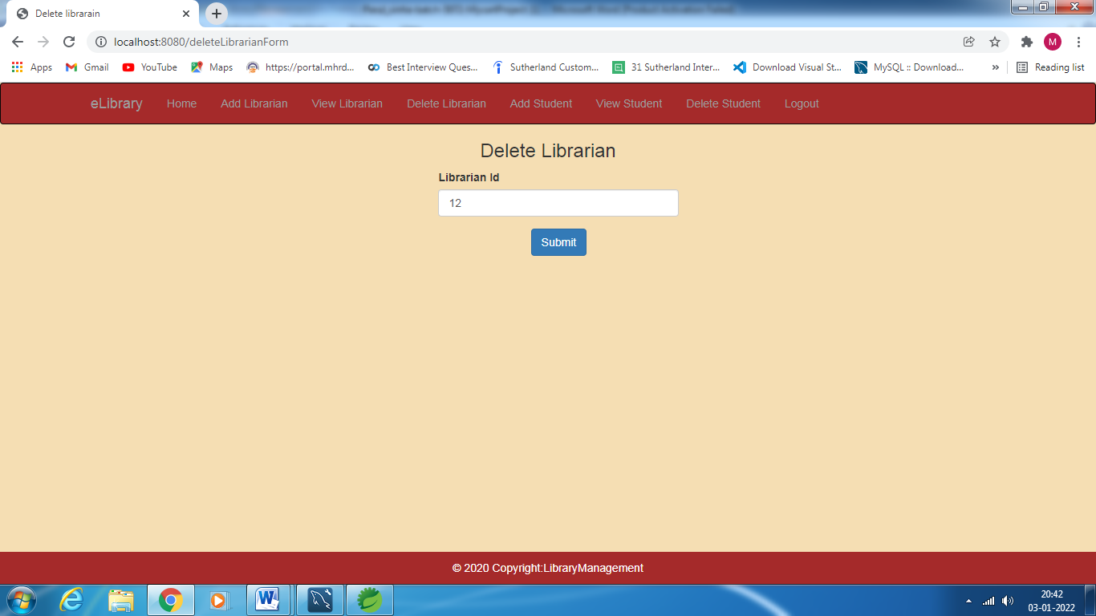

**Add Student Page:**

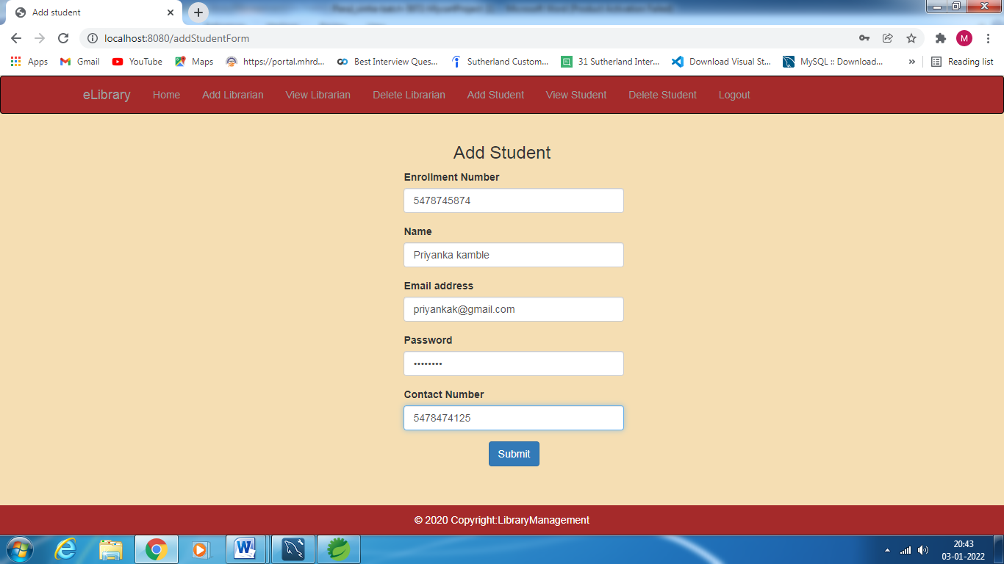

**View Student Page**

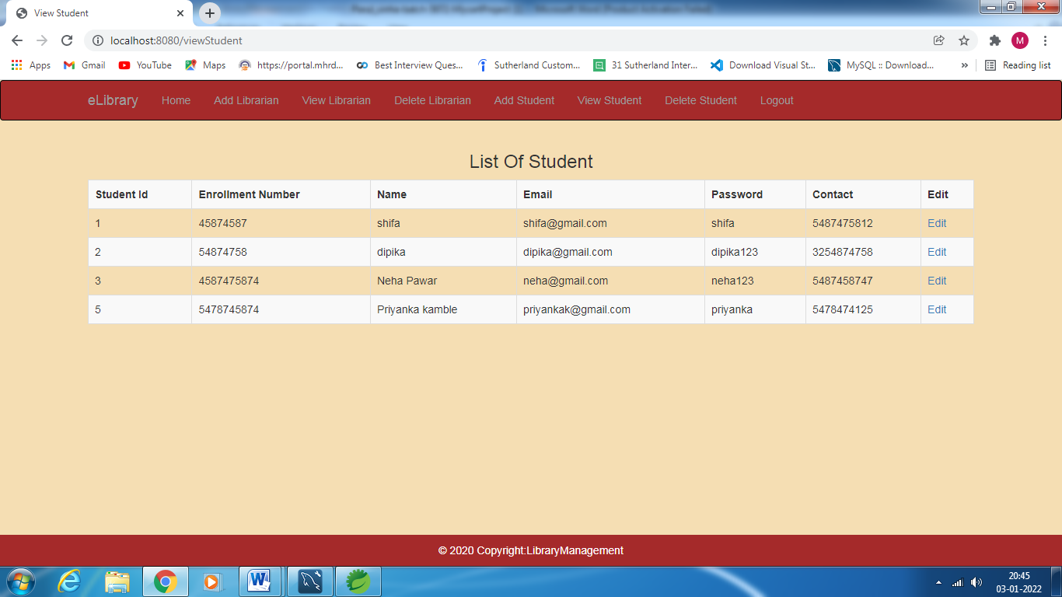

**Edit Student Page:**

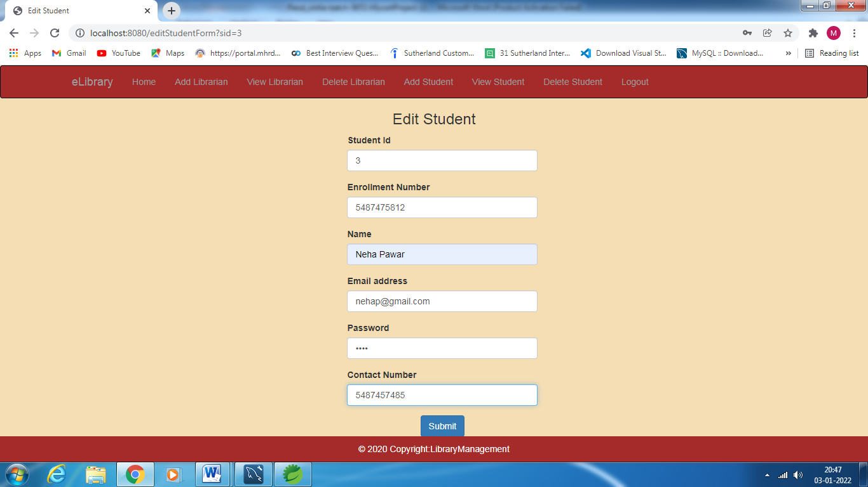

**Delete Student Page:**

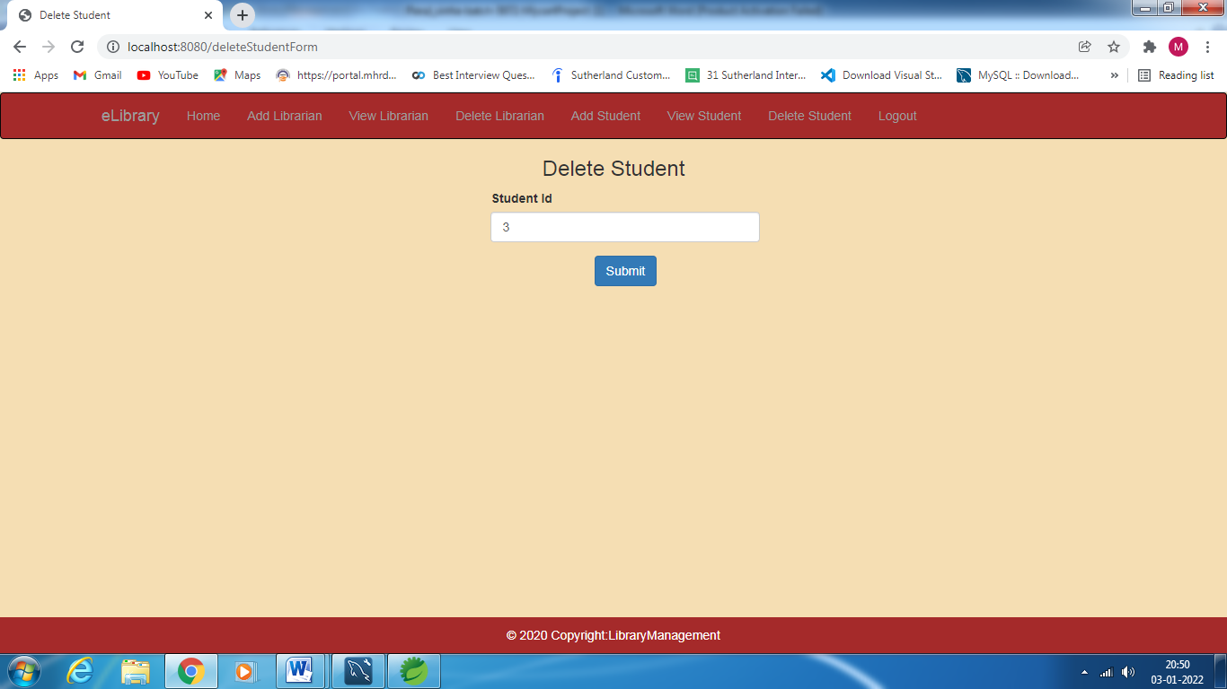

**Librarian Login Page:**

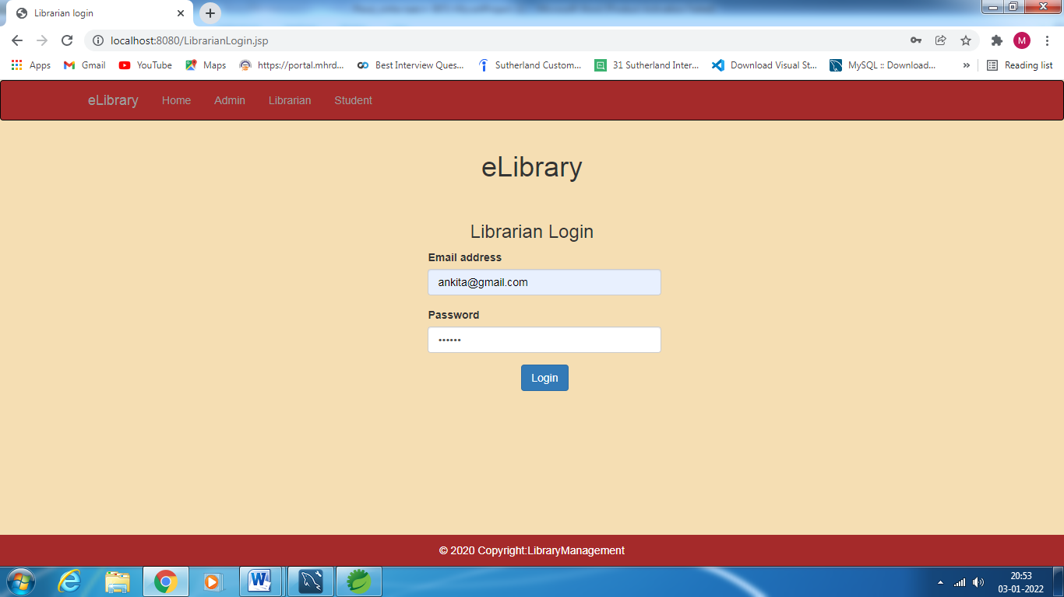

**Librarian Home Page:**

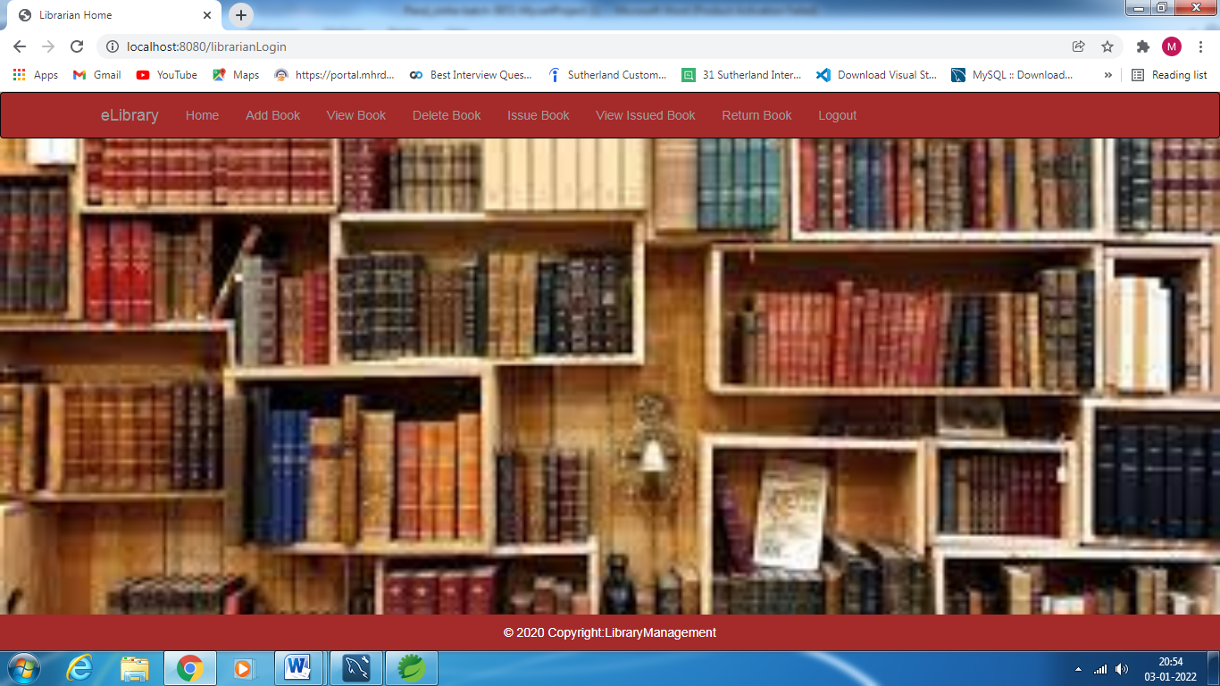

**Add Book Page:**

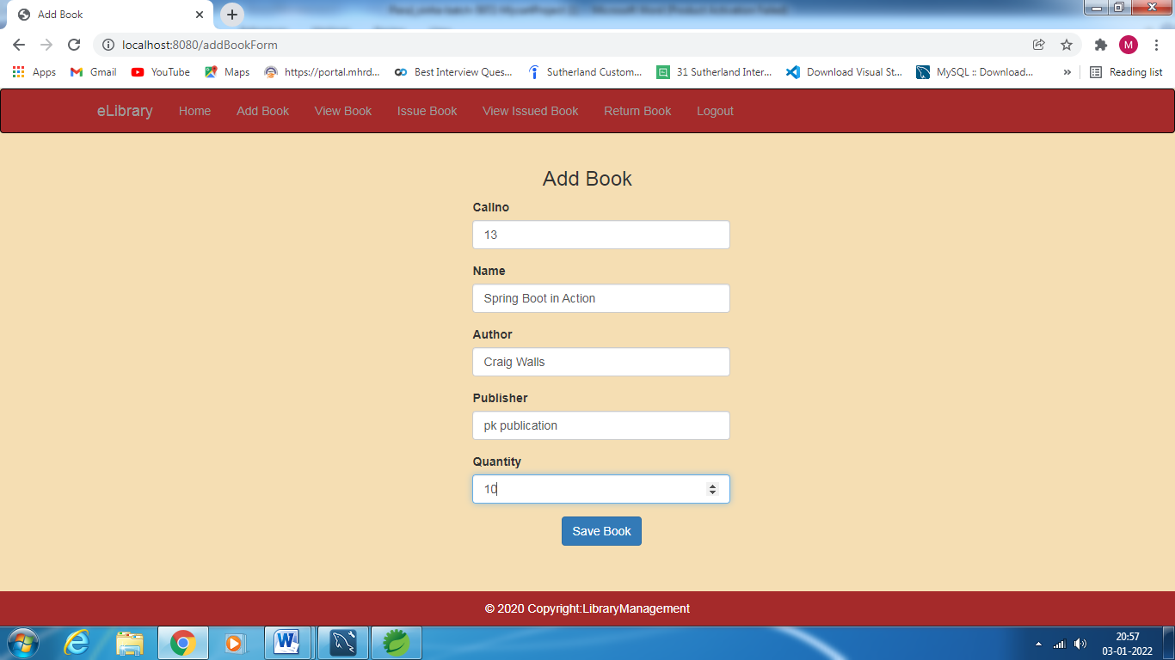

**View Book Page:**

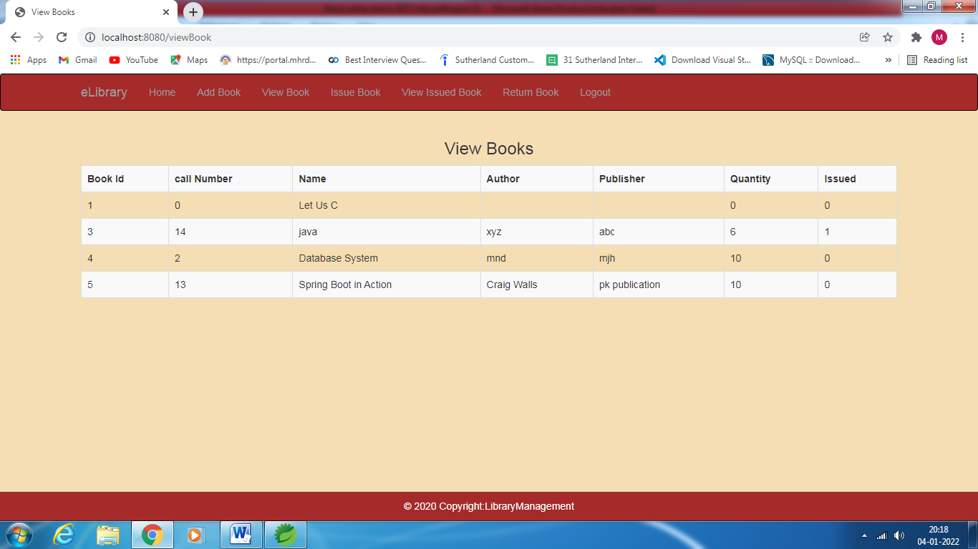

**Issue Book Page:**

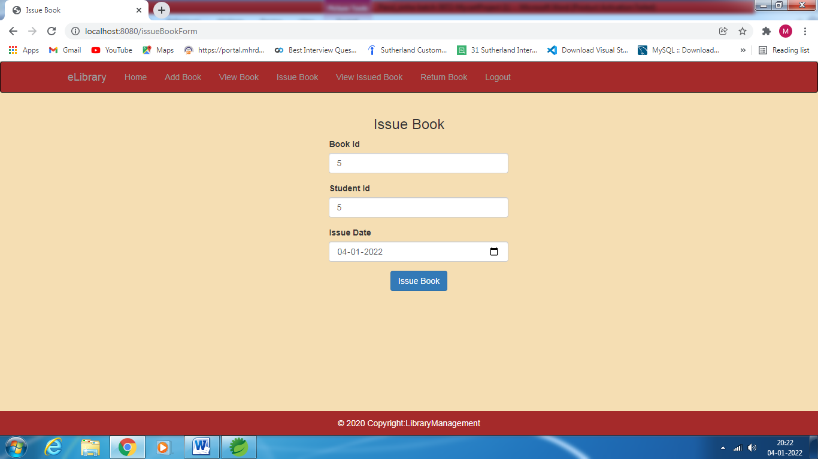

**View Issued Book Page:**

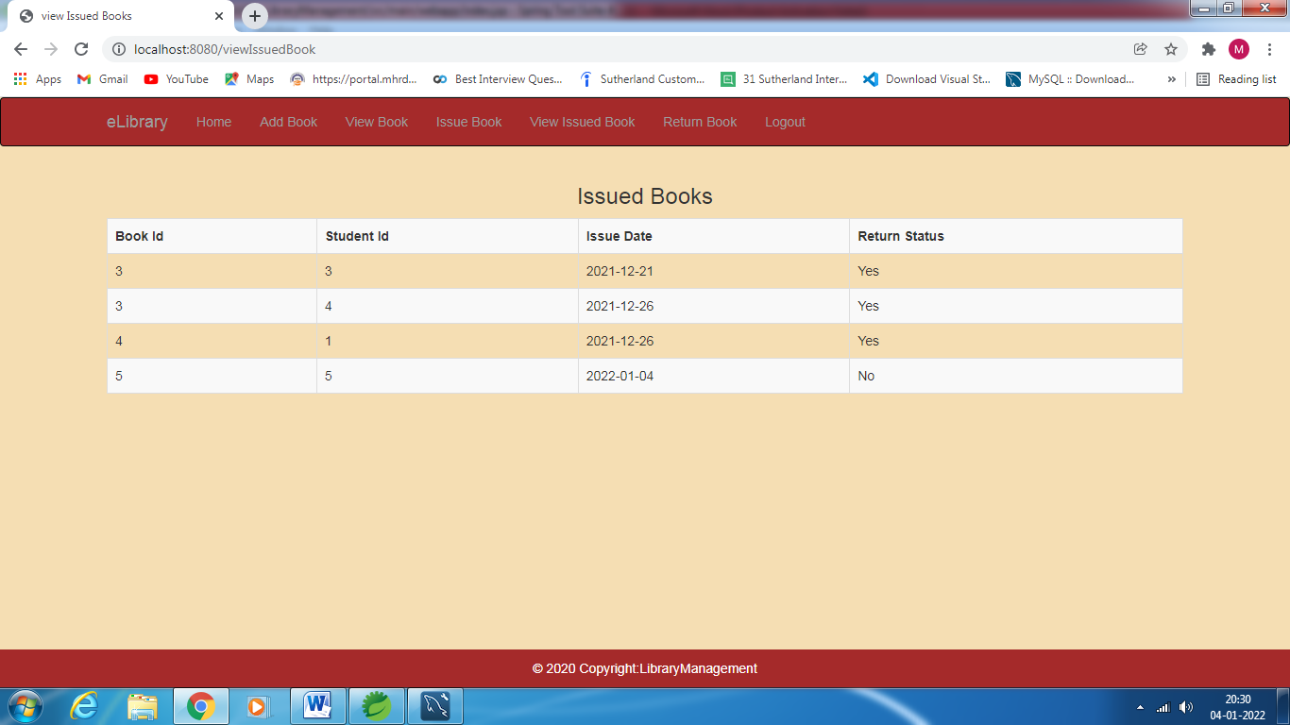

**Return Book Page:**

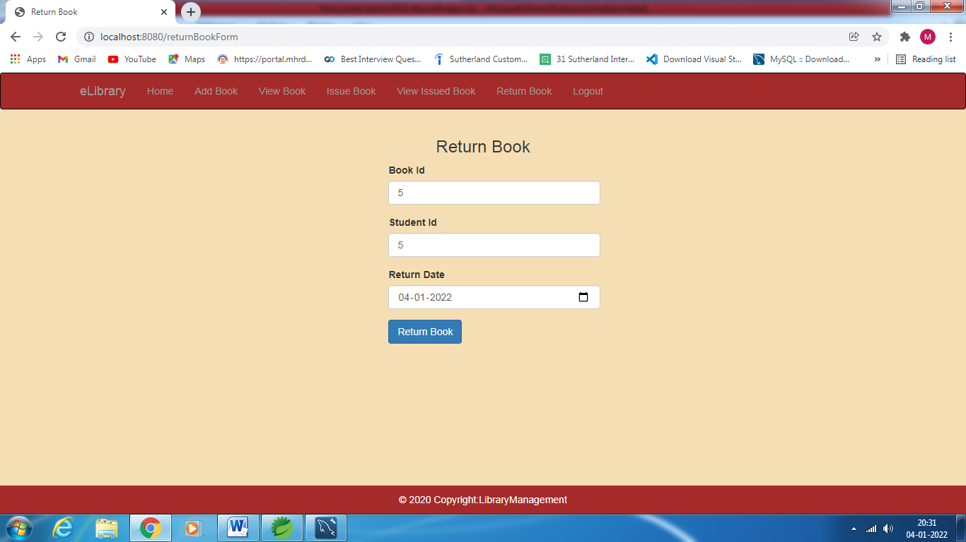

**Student Login Page:**

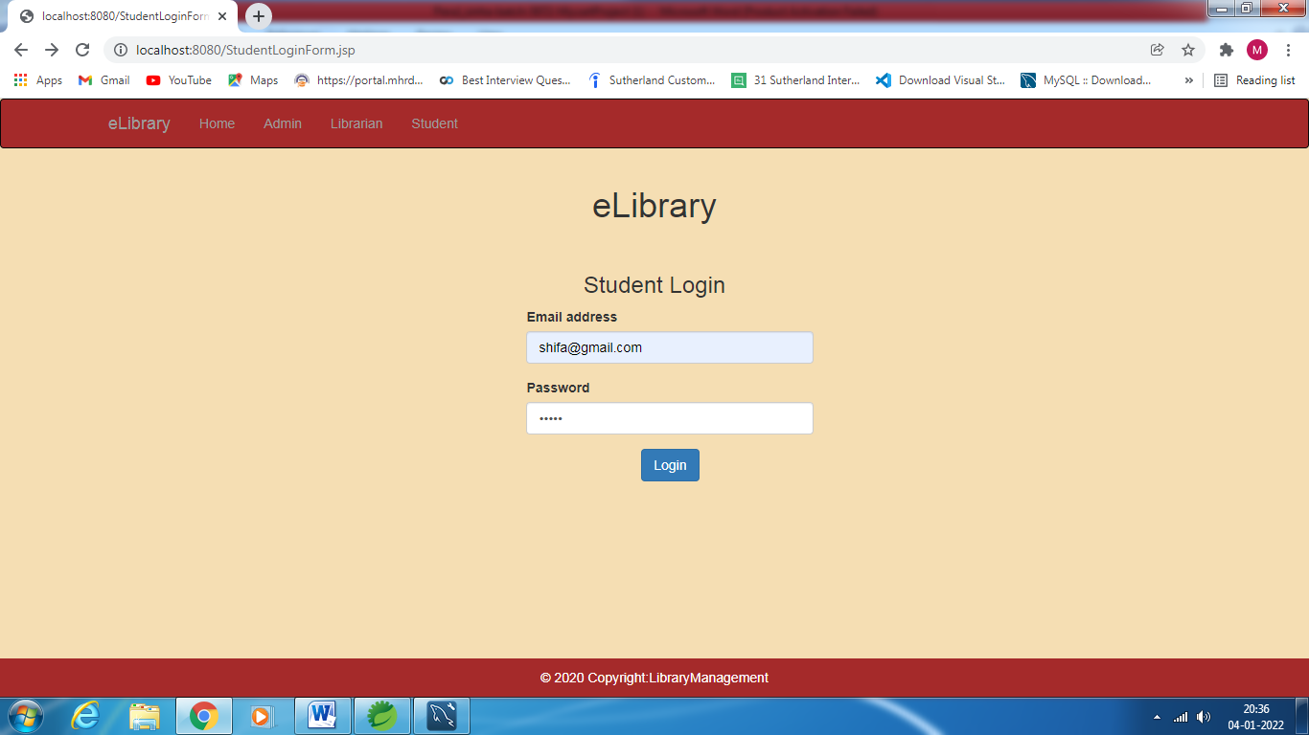

**Student Home Page:**

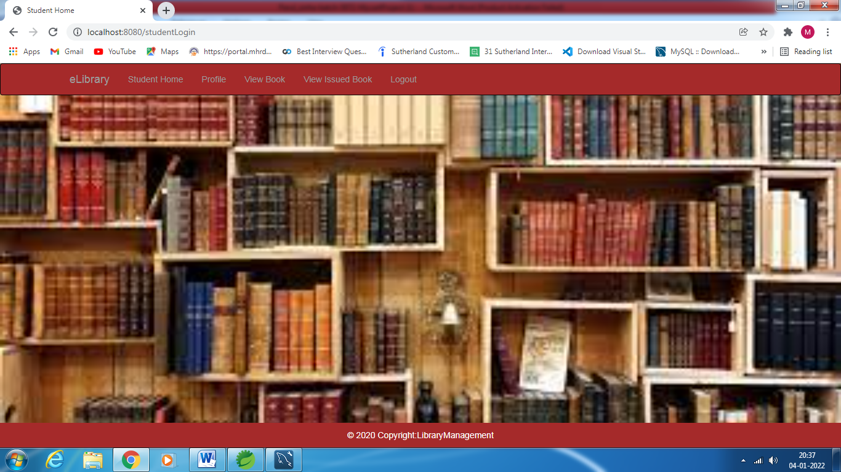

**Student Profile Page:**

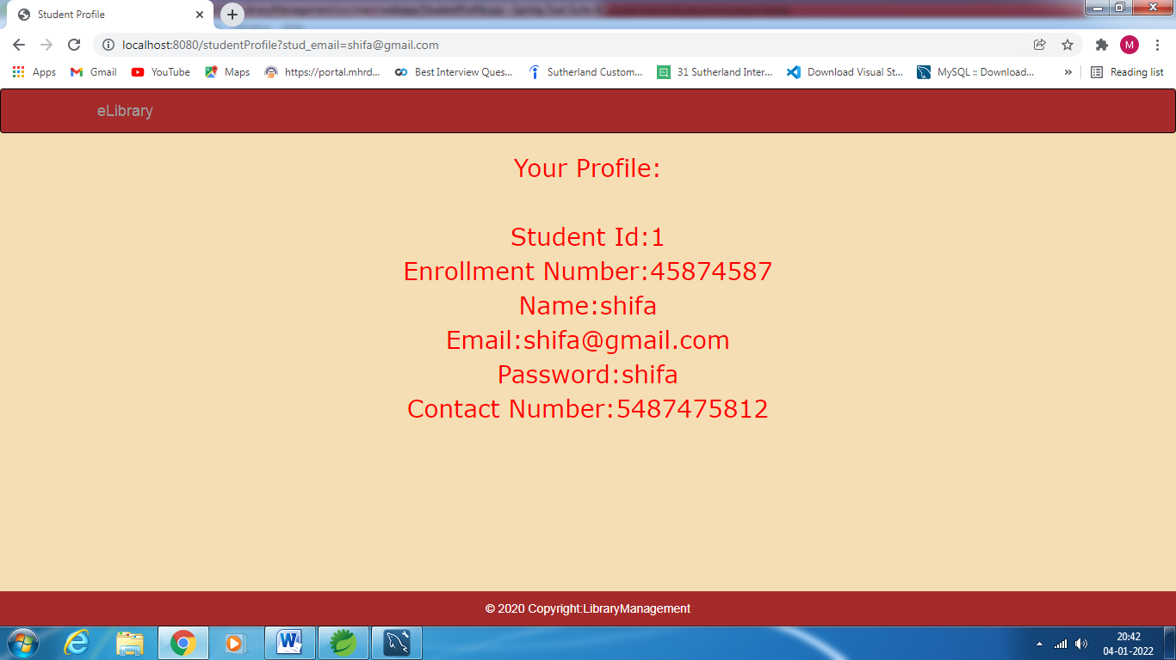

**View Student Issued Book Page:**

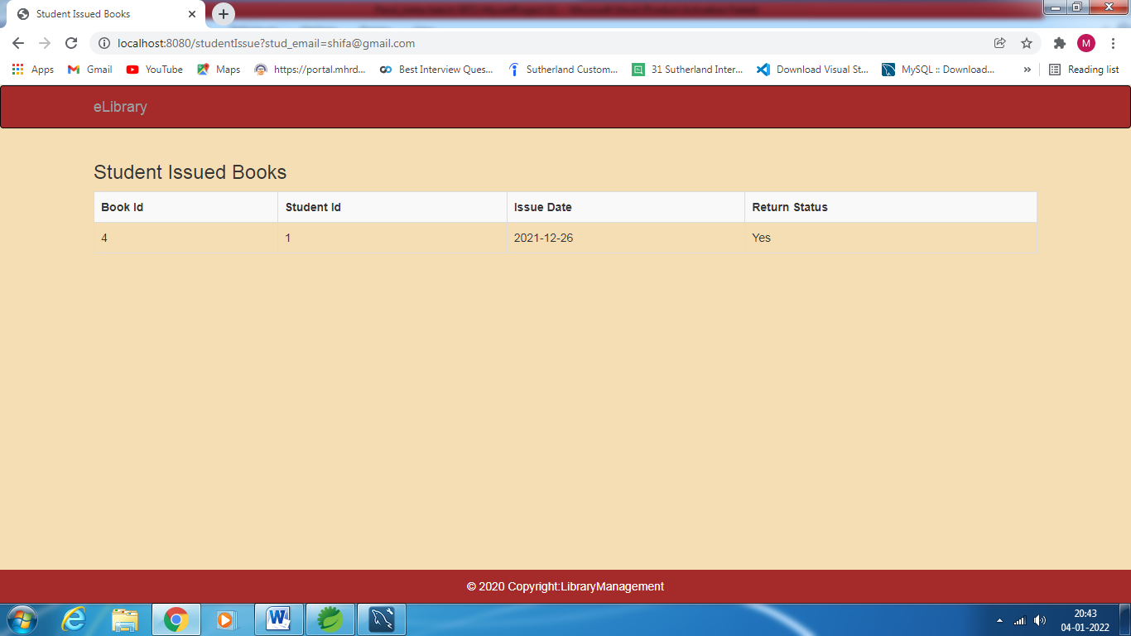

**Thank you**